**Div content wrapper**

# AIFA – Fitness Artificial Intelligence

LOGO

**Navigation**

**Main Section**

ARTICLE

FIGURE

Image map

# [Smart Dumbbell Lifting: Iso-Dynamic Training](http://www.bodybuilding.com/fun/smart-dumbbell-lifting-iso-dynamic-training.html)

BLACKQUOTE

Isometric training can be difficult and tedious, but you can reap its benefits with this overload technique. Pick up two dumbbells and start moving one of them!

by [Nick Tumminello](http://www.bodybuilding.com/fun/nick-tumminello.html)   
Last updated: Dec 18, 2013

The fundamental bodybuilding exercises are considered fundamental because they work. That said, if you're lifting as a lifestyle, not just as a whim, it's important you learn how to vary the basic moves in not-so-basic ways. This will prevent your workouts from growing stale and less effective, and it can help you lift bigger and better when you return to the classic versions.

In this article, I'm showing you how to use what I call "iso-dynamic training" to create a new training stimulus from the staples of your program. Put simply, iso-dynamic training is where, within a set of a given dumbbell exercise, you hold one side in an isometric contraction while the other arm moves through a dynamic (concentric and eccentric) movement. Then, in the same set, you switch so that the side that was doing the isometric moves dynamically.

Sound simple enough? Check out the video to see what I mean.

<iframe width="560" height="315" src="https://www.youtube.com/embed/maJJj7UJF_s" frameborder="0" allowfullscreen></iframe>

**Why To Hold It**

Iso-dynamic movements are overload techniques, like dropsets, assisted reps, or one of my personal favorites, [cheat-centrics](http://www.bodybuilding.com/fun/cheat-centrics-a-better-way-to-perform-cheat-reps.html). These techniques are all ways to subject a muscle group to increased time under tension (TUT), either as a finisher or as a change of pace. READ MORE

Increasing TUT increases metabolic stress, which is one of the three mechanisms for increasing muscle hypertrophy as described in Brad Schoenfeld's seminal 2010 research paper.1 A 2002 study published in the "European Journal of Applied Physiology" further solidified the link between isometric training and metabolic stress—not that anyone who has ever held a heavy dumbbell out to their side for more than a few seconds needed a study to tell them that!2

In fact, a number of studies over the years have confirmed that isometric training can be an effective means of adding muscle. Its downside is, and has always been, that it's boring to remain like a statue for 5 seconds, let alone 30 seconds or more. Iso-dynamic training allows you to reap the hypertrophy benefits of isometric training, but without the risk of falling asleep and dropping a dumbbell on your foot.

As an additional upside, the iso-dynamic techniques described here you will give you an incredible pump, which researchers Bret Contreras and Schoenfeld concluded "causes both an increase in protein synthesis and a decrease in protein breakdown."3,4,5 But aside from the physiological effect, a well-timed pump can also mean the difference between a top placing and a major letdown at a physique competition. That's why you'll see the athletes I work with doing iso-dynamic lifts backstage!

Here are my six favorite movements to use with iso-dynamic training, along with the shrugs mentioned in the video:

**Iso-Dynamic Biceps Curls**

Every bodybuilder loves doing curls, but this version will give you a new appreciation for how tough they can be, while helping walk out of the gym with your biceps inflated like Donald Trump's ego. To perform it, hold your isometric arm's elbow at a 90-degree angle, straight out from the body. READ MORE

On this and all of the other iso-dynamic exercises here, make sure your arm on the isometric side is totally still while the other side moves. Don't let it drop from starting position, no matter how tempting it may be!

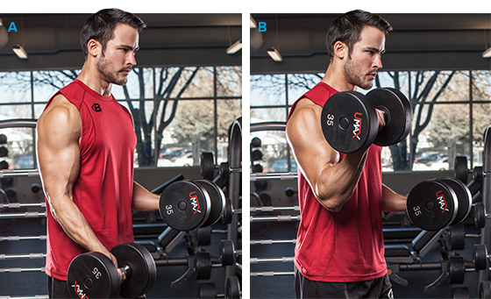

**Iso-Dynamic Biceps Curl**

**Iso-Dynamic Shoulder Raises READ MORE**

This is one of my favorite exercises for figure, physique, and bodybuilding competitors to do before going onstage to compete. It pumps up their shoulders and helps them to look like a "delt-a-saurus." (Full disclosure: I stole "delt-a-saurus" from my beautiful girlfriend and figure competitor Jaclyn Gough.)

To perform it, simply lift two dumbbells up to parallel, but only let one drop. After you perform several reps on the dynamic side, switch so your right arm performs the dynamic reps and your left arm holds isometrically.

**Iso-Dynamic Rear-Delt Flyes READ MORE**

From a bent-over position, raise both your arms out to the side so they are parallel to the floor, as in a standard rear delt flye. Continue holding your right arm where it is while your left arm performs the dynamic reps.

**Iso-Dynamic Shoulder Press READ MORE**

Seated or standing, hold your right arm isometrically in the middle of the range of motion, making a 90-degree angle at the elbow, while your left arm performs a standard, full-range-of-motion overhead press. Once you perform several dynamic reps on your left side, swap arms.

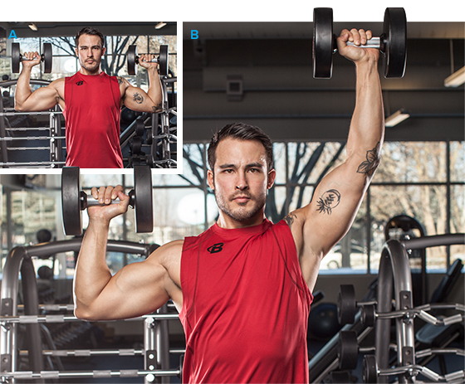

**Iso-Dynamic Shoulder Press**

**Iso-Dynamic Dumbbell Press READ MORE**

Perform the dumbbell press along the same lines as the dumbbell shoulder press. Keep an arm performing the isometric hold at a 90-degree angle, with your humerus (upper-arm bone) parallel to the floor. Don't allow it to droop.

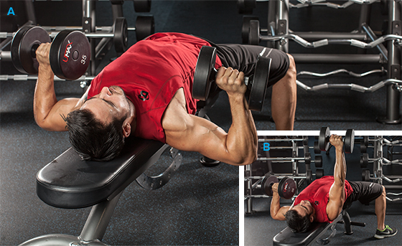

**Iso-Dynamic Dumbbell Press**

**Iso-Dynamic Bent-Over Rows**

This is the opposite of the iso-dynamic dumbbell press. Grab a dumbbell in each hand and assume a bent-over rowing position with your torso parallel to the ground. Then perform a bent-over row with both arms. Hold your right arm at the top of the row while you perform normal rows with your left arm. Then switch.

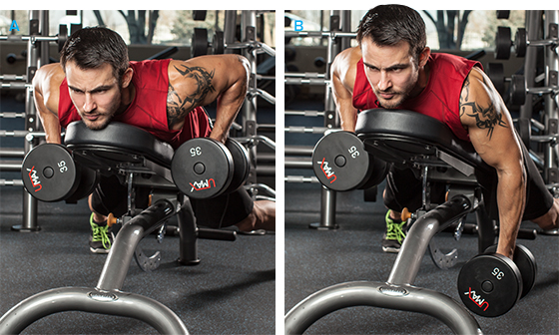

**Iso-Dynamic Dumbbell Rows**

**The Iso-Dynamic Ladder**

Because iso-dynamic reps get progressively more difficult, they're perfect for a descending rep scheme such as a 5-4-3-2 ladder. Perform 5 dynamic reps on your right side while your left side does the isometric hold. Then switch and perform 5 dynamic reps on your left side while your right side performs a hold. Repeat the process doing 4 dynamic reps on each side, and then 3 reps.

To finish, perform two reps in a bilateral fashion, i.e., using both arms simultaneously. If you're struggling for mental clarity at the end of the ladder, remember it this way: two arms for two reps.

I like this scheme because it's easy to remember and accommodates for accumulated fatigue. As the set progresses and fatigue builds, you perform fewer and fewer reps. The last two bilateral reps also allow you to incorporate a little extra body-English if needed. But be aware that when I say "body English" I'm referring to controlled cheating like I covered in my [cheat-centrics article](http://www.bodybuilding.com/fun/cheat-centrics-a-better-way-to-perform-cheat-reps.html), not the type of cheating that puts your back at risk.

**Make it Your Own**

Your rep ladder doesn't have always to always start with 5 reps. You could just as easily start with 4 reps and proceed all the way down to a single rep. Or, you may prefer to start at 8 reps and drop down each time by 2 reps, performing an 8-6-4 ladder.

Adjust the reps accordingly as you see fit, because there is no magic rep scheme. This style of training is meant to be a departure from the norm, so do what you need in order to keep it fresh and challenging!

ASIDE

SECTION

FIGURE

Image map

FIGCAPTION

#### 7 Creative Hacks To Improve Classic Exercises

SECTION

FIGURE

Loss-ingredients.jpg

#### 5 ingredients for the perfect fat loss circuit

Too often, metabolic circuits are little more than a mess of randomly paired movements. Here's the formula for a precise fat-loss workout that will test your limits while providing results!

SECTION

FIGURE

Image map

#### [Gym Hacks You Need To Know](http://www.bodybuilding.com/fun/7-gym-hacks-you-need-to-know.html)

Think outside the box, and your reward will be a better, more efficient workout. Use these 'hacks' to your advantage to become the envy of the weight room

SECTION

FIGURE

Burn-fat-like-crazy.jpg

#### [Burn Fat Like Crazy With 3 Unconventional Cardio Styles!](http://www.bodybuilding.com/fun/burn-fat-like-crazy-with-3-unconventional-cardio-styles.html)

Traditional cardio can be boring, unproductive cardio. Stop walking the treadmill like a zombie and try these alternative workouts that scorch fat and build strength!

SECTION

FIGURE

Hit.jpg

#### [HIIT Can Get You Huge, Especially If You Are A Meathead!](http://www.bodybuilding.com/fun/hiit-can-get-you-huge-especially-if-you-are-meathead.html)

The cardio devil details the effectiveness of HIIT cardio, breaking it down to the cellular level. Learn all you need to know about the science of slim.

SECTION

FIGURE

Hit.jpg

#### 5 keys to doing high-intensity intervals the right way

Cardio may be boring, but at least you'll burn far more calories when you follow these 5 rules for making HIIT workouts vastly more effective.

SECTION

FIGURE

Mistakes-back.png

#### 5 Mistakes Holding Back Your Gains

Don't let your muscle growth be limited by gains-killing mistakes. Easily dodge these 5 common roadblocks with MVP tips from the Twinlab Muscle Militia!

SECTION

FIGURE

Compound-exercise-pic1.png

#### [Compound Exercises Bring Compounded Results: Get More In Less Time!](http://www.bodybuilding.com/fun/powerful_workout_exercises.htm)

Yes, it is possible to get a superior workout - without spending hours in the gym. Make the most of your time by building a routine using these tried and true compound exercises today! Learn more.

SECTION

FIGURE

Image map

#### [Smart Dumbbell Lifting: Iso-Dynamic Training](http://www.bodybuilding.com/fun/smart-dumbbell-lifting-iso-dynamic-training.html)

Isometric training can be difficult and tedious, but you can reap its benefits with this overload technique. Pick up two dumbbells and start moving one of them!